Lab 03: Linear Regression
Lab Outcomes:
- Linear Equation
- Linear Regression.
- Univariate Linear Regression.
- Multivariate Linear Regression.
- Linear Regression Implementation.

Liner Regression:
Linear regression is one of the most basic machine learning models. Its like a ‘hello world’ program of the machine learning. Linear regression is used when there is linear relationship between input variables and output variables. That means we can calculate the values of output variables by using some kind of linear combination of input variables. For example house prices are directly proportional to the house size, no of bedrooms, location etc. There is linear relationship between house prices and factors affecting it.
If there is only one input variable then we call it ‘Single Variable Linear Regression’ or ‘Univariate Linear Regression’. And in case of more than one input variables we call it ‘Multi Variable Linear Regression’ or ‘Multivariate Linear Regression’.

Hypothesis Function:
Linear model hypothesis function is nothing but line function only.

Equation of line is

y = mx + b

where

- m = slope/gradient
- x = input
- b = Y intercept

Lab Tasks:

- Import Required Libraries
Import all the necessary Python libraries for data handling, visualization, and machine learning.

- Load the Dataset
Load the insurance.csv dataset and display the first few rows to get an overview of the data.

- Understand the Dataset
- View the shape and structure of the dataset using appropriate functions.
- Check the data types of all columns.
- Confirm that there are no missing values in the dataset.
- Observe the statistical summary of the data.
- Train Model + Select the Variables for Simple Linear Regression
- Choose one numerical independent variable (e.g., bmi or age) to predict the dependent variable charges.
- Clearly mention which variable you selected and why.
- Also train a model on the complete dataset using all available features (age, bmi, children, sex, smoker, region) to perform Multiple Linear Regression and compare the results with your Simple Linear Regression model.
- Visualize the Relationship
- Create a scatter plot to visualize the relationship between the selected independent variable and the dependent variable (charges).
- Observe whether the relationship appears to be linear.
- Split the Data
- Split the dataset into training (80%) and testing (20%) sets.
- Mention why this step is important.
- Train the Model
- Train a simple linear regression model using the selected independent variable to predict charges.
- Display the regression coefficients (intercept and slope) obtained from the model.
- Evaluate the Model
- Calculate and display appropriate evaluation metrics such as:
  - Mean Absolute Error (MAE)
  - R-squared (R²) score
- Plot the Regression Line
- Plot the best-fit regression line over the scatter plot of actual data points.
- Label the axes properly and include a title.
- Visualize Model Performance
- Draw a scatter plot comparing actual vs predicted charges.

- Make Predictions on New Data
- Create a few hypothetical input values (e.g., new BMI or age values).
- Use the trained model to predict the corresponding insurance charges for these new inputs.
- Interpret the Results
- Explain briefly (in Text Cells or notebook markdown):
  - What does the regression coefficient indicate about the relationship?
  - How well does the model fit the data based on MAE and R² value?

Dataset Link: https://www.kaggle.com/datasets/mirichoi0218/insurance
Dataset Description:
This dataset provides information about individuals’ demographics, BMI, number of children, smoking habits, and residential region, along with their annual medical insurance charges.
Your goal is to understand and model the relationship between these factors and the insurance charges using Linear Regression.
Feature Description:
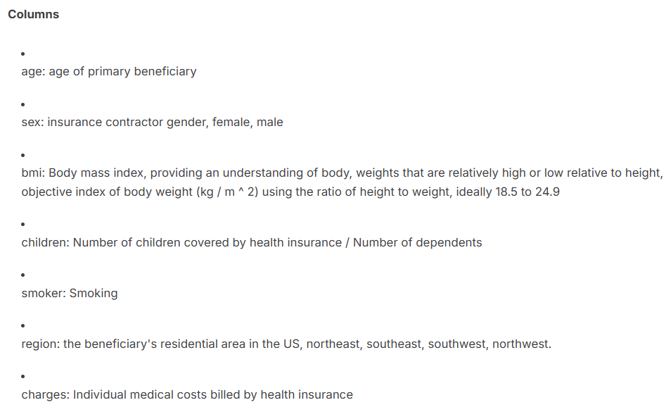

Lab # 03 Marks distribution
 | ER1 | ER6 | ER8
Task | 3 points | 3 points | 4 points

Lab # 03 Rubric Evaluation Guideline:
# | Qualities & Criteria | 0 < Poor <= 1 | 1 < Satisfactory <= 2 | 2 < Excellent <=3
ER1 | Task Completion | Minimal or no program functionality was achieved. | Some tasks were completed, but the program has errors or incomplete functionalities. | All tasks were completed, and the program runs without errors.
# | Qualities & Criteria | 0 < Poor <= 1 | 1 < Satisfactory <= 2 | 2 < Excellent <=3
ER6 | Program Output | Output is inaccurate or poorly presented. | Output is mostly accurate but may lack labels, captions, or formatting. | Output is clear, accurate, and well presented with labels, captions, and proper formatting.
# | Qualities & Criteria | 0 < Poor <= 1 | 1.5 < Satisfactory <= 2.5 | 2.5 < Excellent <= 4
ER8 | Question & Answer | Answers some questions but not confidently or based on lab task knowledge. | Answers most questions confidently and based on lab task knowledge. | Answers all questions confidently and demonstrates a deep understanding of the given lab task.

